Using both primary and secondary sources, evaluate the validity of a claim about US history that appeared on social media during the last ten years. The claim may be explicit or implicit and must refer to the time period 1865-1990. The bulk of your paper should be devoted to evaluating the relative value of the sources you use.
The purpose of this assignment is to advance your ability to reason through a specific historical question and to communicate through written text your ideas. Thus: Your paper should critically consider the issue/problem and deliver all relevant information. You should also provide a clear thesis statement. In a paper this size, your introduction and thesis should appear in the first paragraph. Make sure to paraphrase your sources accurately. In other words, state what the source says, not what you wished it said or thought it said. You need to state the evidence fairly, even if you think it wrong or offensive. Your paper should use evidence to answer the historical question. Your paper should develop and organize your thoughts clearly and logically. Outlining is a necessary, but not required, step in writing a well-organized paper. Your paper should draw a conclusion that addresses the paper’s chief topic or question and that states your answer to the question or your contribution to the topic.
Formatting:
Your paper needs to be typed, double spaced, 12 pt. Times New Roman font. You will need to cite your sources using the Chicago Manual of Style. Here is a link to an online resource for those unfamiliar with this style:
https://www.chicagomanualofstyle.org
You will need to use footnotes for in text citations and your paper needs to have a works cited (bibliography) page with the sources you used in your paper.

This Paper is due in stages throughout the first half of the semester, with the final revised version being due on September 30th.
The paper will be due
By submitting your common core assignment, you accept that it will be checked by SafeAssign for plagiarism. The punishment for Academic Honesty Policy violations are listed in the TSU Student Code of Conduct (www.tsu.edu/ssp/2015-TSU-Student-Code-of-Conduct.pdf) and your Professor’s syllabus. You will need to submit your paper in either a pdf or a .doc format.
The following are examples of social media claims about history. In some cases, the claim is obvious; in others, it is implicit. (For example, the Theodore Roosevelt meme makes a claim about the nature of early twentieth-century masculinity and invites you to discuss which aspects of his career are being thus stereotyped as “male.”) You may use one of these images as the subject of your essay or find your own.

1.
2.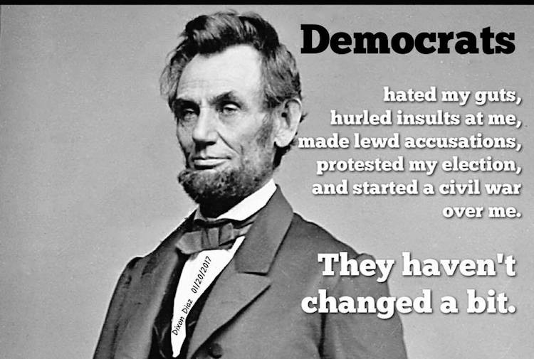 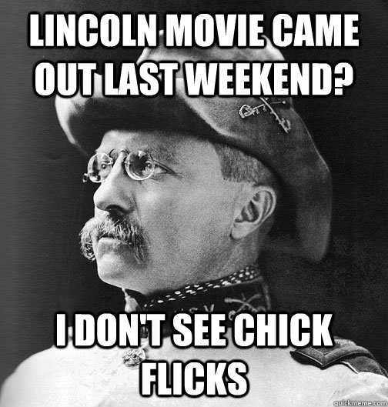
3.
